File permissions in Linux

Project description
In this scenario. I work as a security specialist for a sizable company. Mostly, I collaborate with their research team. Making sure team members have the necessary authorizations and permissions is a part of my job. This maintains the system's security. I have to check the file system's current permissions. I have to determine whether the permissions correspond to the proper authorization. I would need to change the permissions to authorize the right users and stop any unauthorized access if they don't match.

Check file and directory details
I used the ls -la command after using cd projects command to view the permissions in the projects directory
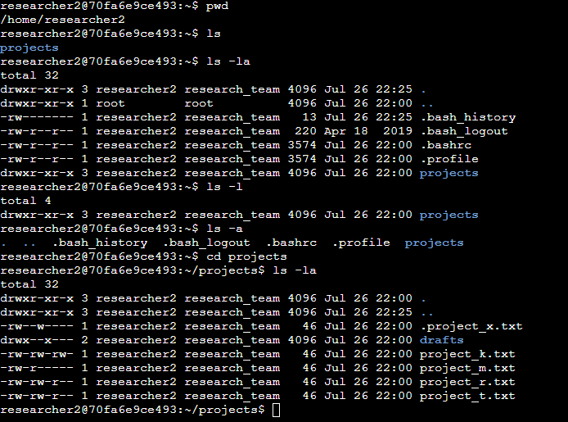

Describe the permissions string
As an example The project directory permissions is shown with drwxr-xr-x
This means the directory of the project is read, writable, and executable by the user. For the group it is only readable and executable, the group cannot change the files in this directory. The group permissions also apply to the others permissions.

Change file permissions
The organization states that others are not allowed to write on files. As shown in the project permissions the file project_k.txt is writable by others. To change this permission we use chmod o-w project_k.txt to remove the write permissions from others on the file.
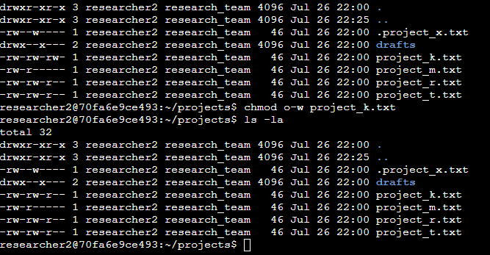

Change file permissions on a hidden file
We also saw on the hidden file the same scenario except we need to enable read permission for this hidden file. We used the command chmod u-w,g+r,g-w .project_x.txt. u-w and g-w disabled write permissions from the group and user, g+r enabled read permission to the group. Then including a . before the project name indicates the hidden file status.
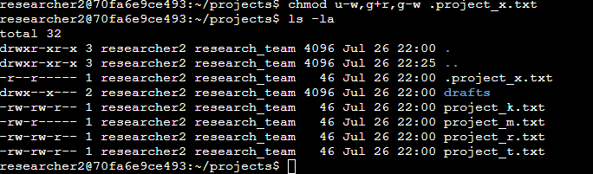

Change directory permissions
The files and directories in the projects directory belong to the researcher2 user. Only researcher2 should be allowed to access the drafts directory and its contents. To change the directory as a whole, we navigate back to researcher 2, then we use the command chmod again to remove the group and other permissions from reading, writing and executing.
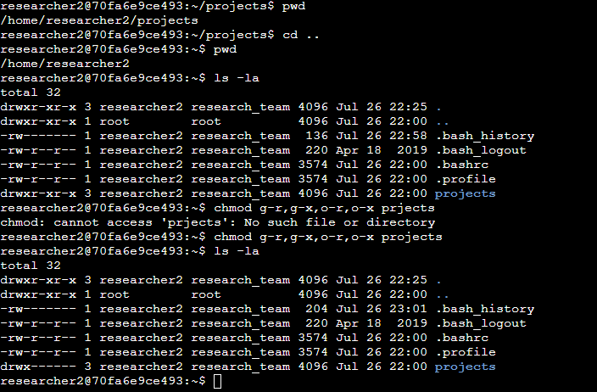

Summary
In short, we inspected the permissions of each file and directory from researcher2 and changed the permissions to match the company authorization guidelines. After completing the assignment.

This is the final result from the BASH terminal

researcher2@70fa6e9ce493:~$ pwd
/home/researcher2
researcher2@70fa6e9ce493:~$ ls
projects
researcher2@70fa6e9ce493:~$ ls -la
total 32
drwxr-xr-x 3 researcher2 research_team 4096 Jul 26 22:25 .
drwxr-xr-x 1 root root 4096 Jul 26 22:00 ..
-rw------- 1 researcher2 research_team 13 Jul 26 22:25 .bash_history
-rw-r--r-- 1 researcher2 research_team 220 Apr 18 2019 .bash_logout
-rw-r--r-- 1 researcher2 research_team 3574 Jul 26 22:00 .bashrc
-rw-r--r-- 1 researcher2 research_team 3574 Jul 26 22:00 .profile
drwxr-xr-x 3 researcher2 research_team 4096 Jul 26 22:00 projects
researcher2@70fa6e9ce493:~$ ls -l
total 4
drwxr-xr-x 3 researcher2 research_team 4096 Jul 26 22:00 projects
researcher2@70fa6e9ce493:~$ ls -a
. .. .bash_history .bash_logout .bashrc .profile projects
researcher2@70fa6e9ce493:~$ cd projects
researcher2@70fa6e9ce493:~/projects$ ls -la
total 32
drwxr-xr-x 3 researcher2 research_team 4096 Jul 26 22:00 .
drwxr-xr-x 3 researcher2 research_team 4096 Jul 26 22:25 ..
-rw--w---- 1 researcher2 research_team 46 Jul 26 22:00 .project_x.txt
drwx--x--- 2 researcher2 research_team 4096 Jul 26 22:00 drafts
-rw-rw-rw- 1 researcher2 research_team 46 Jul 26 22:00 project_k.txt
-rw-r----- 1 researcher2 research_team 46 Jul 26 22:00 project_m.txt
-rw-rw-r-- 1 researcher2 research_team 46 Jul 26 22:00 project_r.txt
-rw-rw-r-- 1 researcher2 research_team 46 Jul 26 22:00 project_t.txt
researcher2@70fa6e9ce493:~/projects$ chmod o-w project_k.txt
researcher2@70fa6e9ce493:~/projects$ ls -la
total 32
drwxr-xr-x 3 researcher2 research_team 4096 Jul 26 22:00 .
drwxr-xr-x 3 researcher2 research_team 4096 Jul 26 22:25 ..
-rw--w---- 1 researcher2 research_team 46 Jul 26 22:00 .project_x.txt
drwx--x--- 2 researcher2 research_team 4096 Jul 26 22:00 drafts
-rw-rw-r-- 1 researcher2 research_team 46 Jul 26 22:00 project_k.txt
-rw-r----- 1 researcher2 research_team 46 Jul 26 22:00 project_m.txt
-rw-rw-r-- 1 researcher2 research_team 46 Jul 26 22:00 project_r.txt
-rw-rw-r-- 1 researcher2 research_team 46 Jul 26 22:00 project_t.txt
researcher2@70fa6e9ce493:~/projects$ chmod u-w,g+r,g-w .project_x.txt
researcher2@70fa6e9ce493:~/projects$ ls -la
total 32
drwxr-xr-x 3 researcher2 research_team 4096 Jul 26 22:00 .
drwxr-xr-x 3 researcher2 research_team 4096 Jul 26 22:25 ..
-r--r----- 1 researcher2 research_team 46 Jul 26 22:00 .project_x.txt
drwx--x--- 2 researcher2 research_team 4096 Jul 26 22:00 drafts
-rw-rw-r-- 1 researcher2 research_team 46 Jul 26 22:00 project_k.txt
-rw-r----- 1 researcher2 research_team 46 Jul 26 22:00 project_m.txt
-rw-rw-r-- 1 researcher2 research_team 46 Jul 26 22:00 project_r.txt
-rw-rw-r-- 1 researcher2 research_team 46 Jul 26 22:00 project_t.txt
researcher2@70fa6e9ce493:~/projects$ pwd
/home/researcher2/projects
researcher2@70fa6e9ce493:~/projects$ cd ..
researcher2@70fa6e9ce493:~$ pwd
/home/researcher2
researcher2@70fa6e9ce493:~$ ls -la
total 32
drwxr-xr-x 3 researcher2 research_team 4096 Jul 26 22:25 .
drwxr-xr-x 1 root root 4096 Jul 26 22:00 ..
-rw------- 1 researcher2 research_team 136 Jul 26 22:58 .bash_history
-rw-r--r-- 1 researcher2 research_team 220 Apr 18 2019 .bash_logout
-rw-r--r-- 1 researcher2 research_team 3574 Jul 26 22:00 .bashrc
-rw-r--r-- 1 researcher2 research_team 3574 Jul 26 22:00 .profile
drwxr-xr-x 3 researcher2 research_team 4096 Jul 26 22:00 projects
researcher2@70fa6e9ce493:~$ chmod g-r,g-x,o-r,o-x prjects
chmod: cannot access 'prjects': No such file or directory
researcher2@70fa6e9ce493:~$ chmod g-r,g-x,o-r,o-x projects
researcher2@70fa6e9ce493:~$ ls -la
total 32
drwxr-xr-x 3 researcher2 research_team 4096 Jul 26 22:25 .
drwxr-xr-x 1 root root 4096 Jul 26 22:00 ..
-rw------- 1 researcher2 research_team 204 Jul 26 23:01 .bash_history
-rw-r--r-- 1 researcher2 research_team 220 Apr 18 2019 .bash_logout
-rw-r--r-- 1 researcher2 research_team 3574 Jul 26 22:00 .bashrc
-rw-r--r-- 1 researcher2 research_team 3574 Jul 26 22:00 .profile
drwx------ 3 researcher2 research_team 4096 Jul 26 22:00 projects

